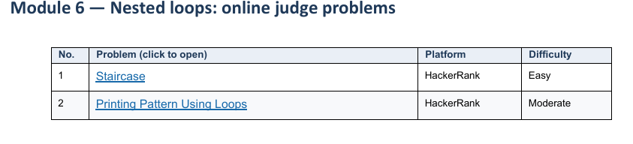
1 Staircase HackerRank
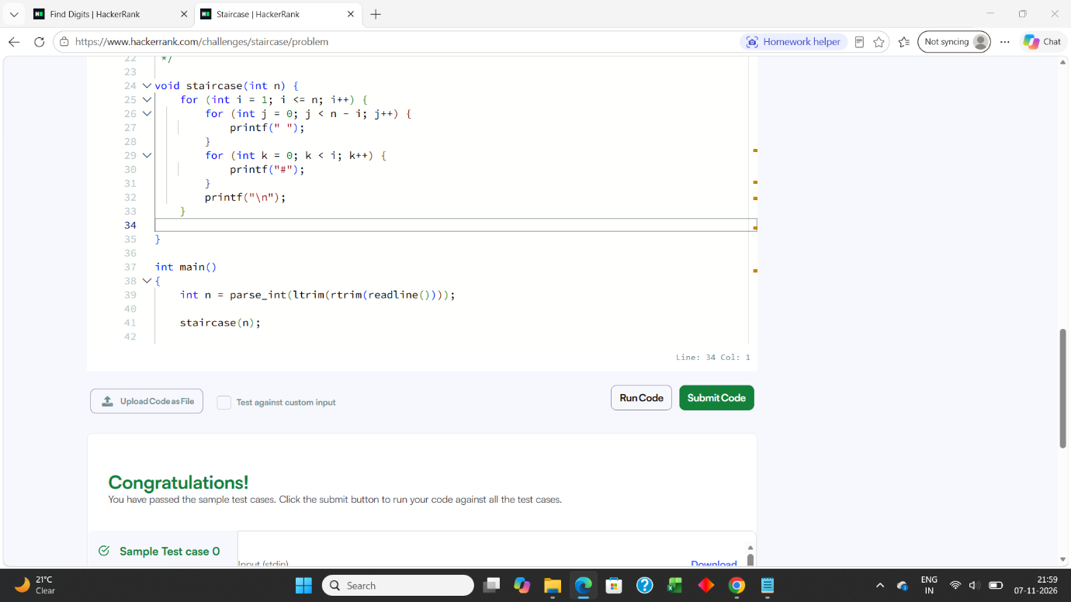
2 Printing Pattern Using Loops HackerRank


